Movies Database Project Content Strategy Analysis

Visualization Report
  - 1. Introduction
Business Context
StreamFlix is transitioning from a free ad-supported model to a subscription-based streaming service. Understanding user preferences, demographics, and engagement patterns is essential for increasing subscriber retention and attracting new users.
Objectives
The purpose of this analysis is to:
- Identify highly rated content among different subscription segments.
- Understand genre preferences and viewing patterns.
- Analyze user demographics and geographic distribution.
- Examine device usage behavior.
- Provide insights to support content acquisition, marketing, and subscription growth strategies.
  - 2. Data Sources
The analysis was performed using three datasets:
Dataset | Description
Movies | Movie information including title, genre, language, country and total views
Users | User demographic information including age group, country, subscription status and device
Ratings | User ratings assigned to movies
The datasets were stored in SQL Server and queried using SQL. Python was used for data extraction and visualization.
  - 3. Tools and Technologies
- SQL Server
- SQL
- Python
- Pandas
- PyODBC
- Matplotlib

  - 4. Visualization Analysis
Top 10 Highest Rated Movies

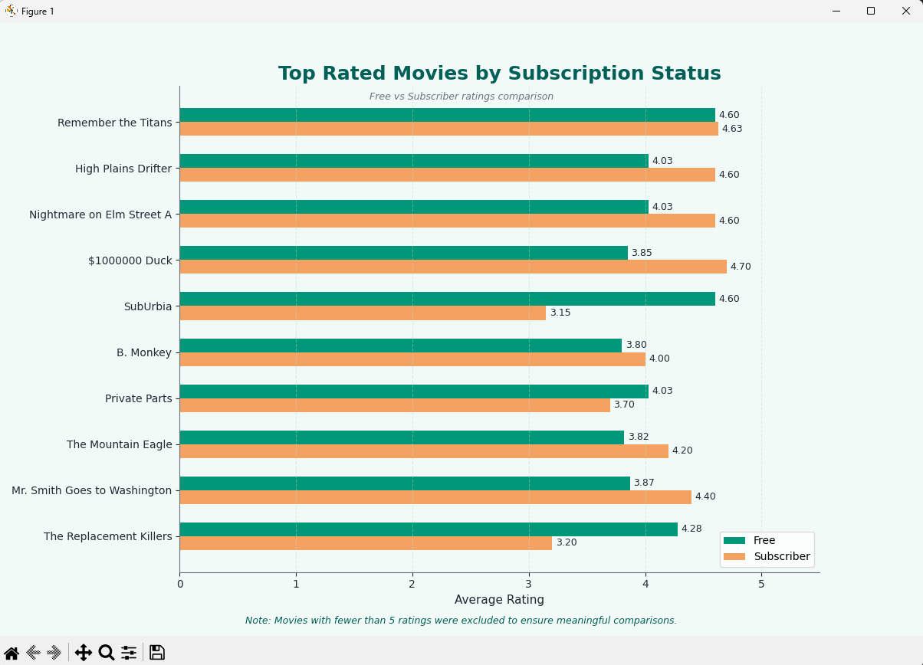

Description
This chart compares the average ratings assigned by Free and Subscriber users for the highest-rated movies. Movies with fewer than five ratings were excluded to ensure meaningful comparisons.
Key Insights
- Subscriber users generally assign higher ratings than Free users.
- Remember the Titans receives consistently high ratings from both groups.
- Movies such as $1000000 Duck, Mr. Smith Goes to Washington, and The Mountain Eagle are rated more positively by Subscriber users.
- Significant rating differences for SubUrbia and The Replacement Killers suggest varying preferences between Free and Subscriber users.
Business Implications
- Highly rated titles among Subscriber users could be promoted to Free users to encourage upgrades.
- Differences in ratings between user segments indicate opportunities for personalized recommendations.
- Understanding content preferences by subscription type can support retention and conversion strategies.

Most Popular Genres
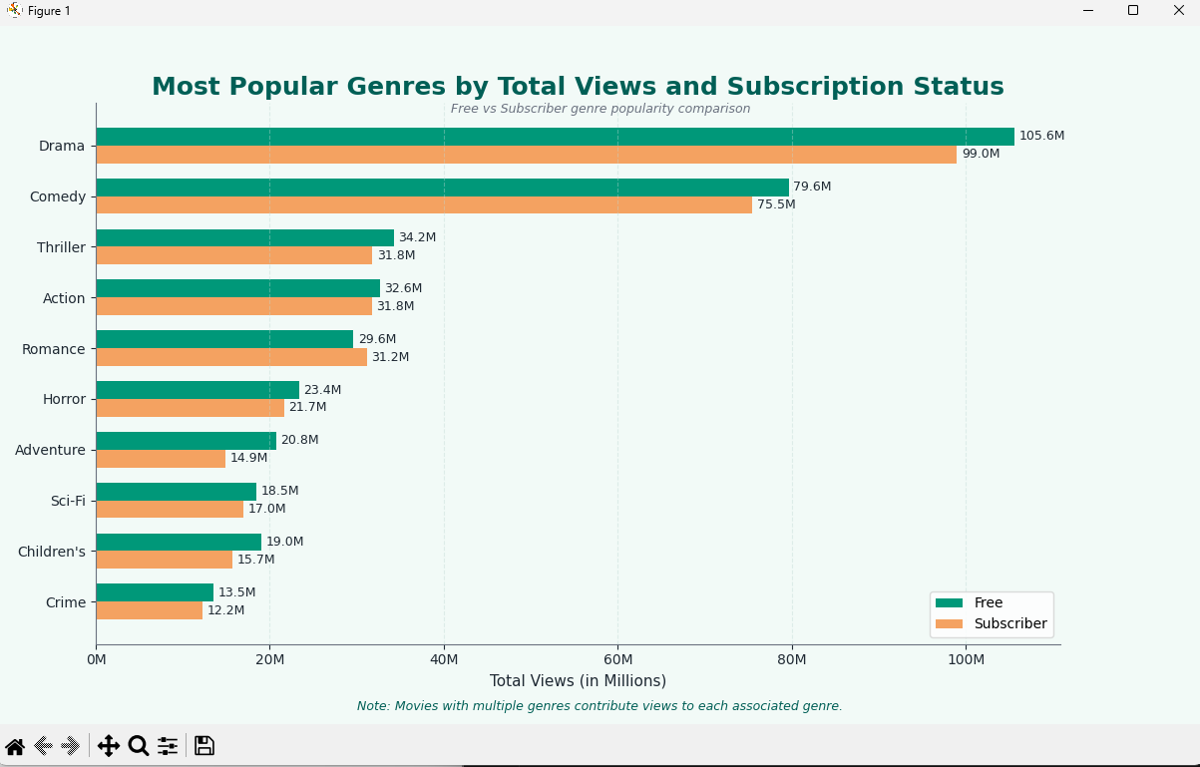

Description
This chart compares the popularity of genres based on total views among Free and Subscriber users. Movies associated with multiple genres contribute their views to each corresponding genre.
Key Insights
- Drama is the most popular genre among both Free and Subscriber users.
- Comedy ranks second and exhibits strong engagement across both groups.
- Thriller and Action have comparable popularity among Free and Subscriber users.
- Subscriber users show relatively stronger engagement with Romance.
- Free users generate higher total views across most genres, indicating they likely constitute a larger user segment.
Business Implications
- Drama and Comedy should remain priorities for content acquisition and promotional campaigns.
- Differences in genre preferences can support personalized recommendations.
- Content popular among Subscriber users can be used to increase retention and engagement.
- Understanding viewing preferences across user segments can support subscription growth strategies.

User Distribution By Age Group
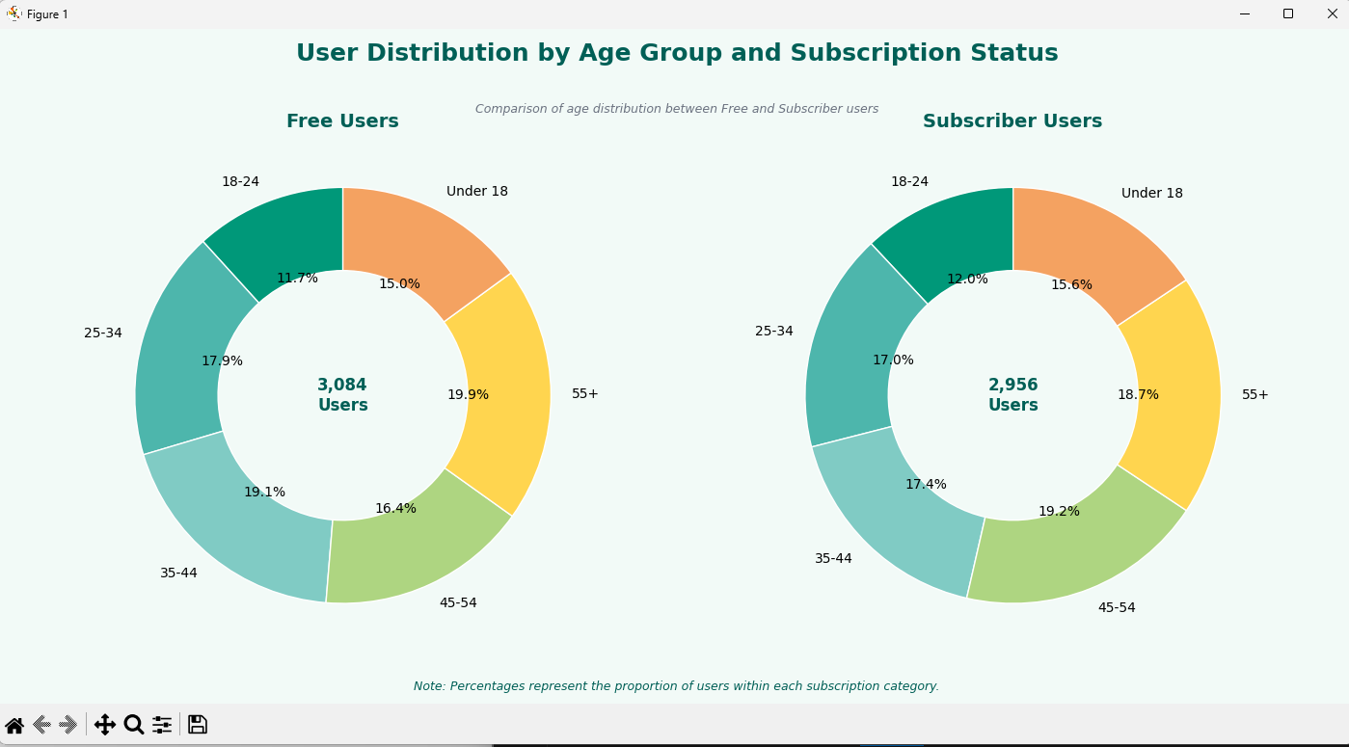

Description
This figure compares the age distribution of Free and Subscriber users across six age groups. The total number of users in each subscription category is displayed in the center of the donut charts.
Key Insights
- User distributions are broadly similar between Free and Subscriber users.
- The 35–44 and 55+ age groups account for the largest proportions of users.
- Users aged 18–24 represent the smallest segment of the user base.
- Subscriber users have a slightly higher representation in the 45–54 age group.
Business Implications
- The platform serves a diverse age range, with no single age group dominating the user base.
- Marketing campaigns can be tailored to middle-aged segments, which represent a substantial proportion of users.
- Similar age distributions suggest that content preferences may have a stronger influence on subscription decisions than age demographics.

Distribution of Users By Subscription Status
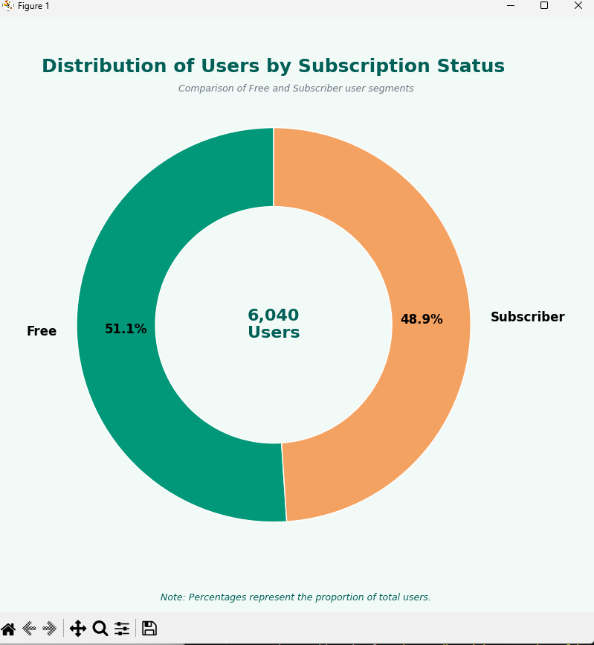

Description
This figure illustrates the overall composition of the user base by subscription type. The total number of users is displayed in the center of the donut chart, while percentages indicate the proportion of each user segment.
Key Insights
- Free and Subscriber users are almost evenly distributed across the platform.
- Free users represent 51.1% of the total user base.
- Subscriber users account for 48.9% of users, indicating strong subscription adoption.
Business Implications
- The large Free user segment provides opportunities for conversion into paid subscriptions.
- A healthy proportion of Subscriber users demonstrates strong customer engagement.
- Retention and personalized marketing strategies should focus on maximizing value from both user groups.

User Distribution by Country

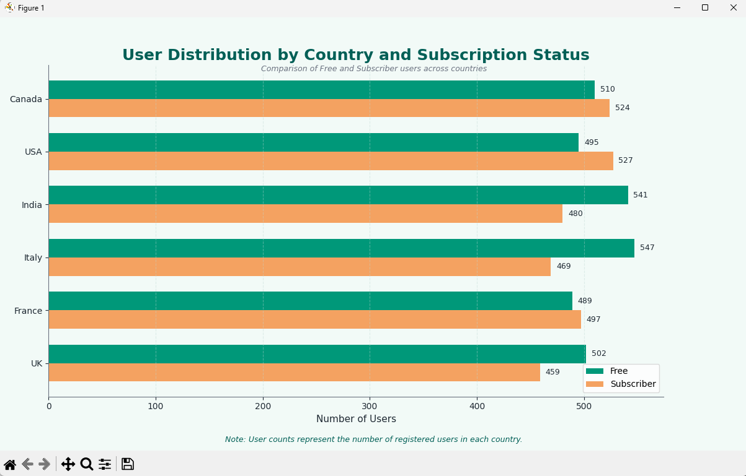

Description
This figure compares the number of Free and Subscriber users across countries.
Key Insights
- User counts are relatively balanced across countries.
- Italy and India have the largest Free user populations.
- Canada and the USA have slightly more Subscriber users.
- The differences between Free and Subscriber users are generally small, indicating consistent subscription adoption across regions.
Business Implications
- Countries with larger Free user bases present opportunities for subscription conversion.
- Markets with stronger Subscriber representation may benefit from retention and loyalty campaigns.
- Broad geographic distribution indicates strong international engagement.

Distribution of Device Users among users
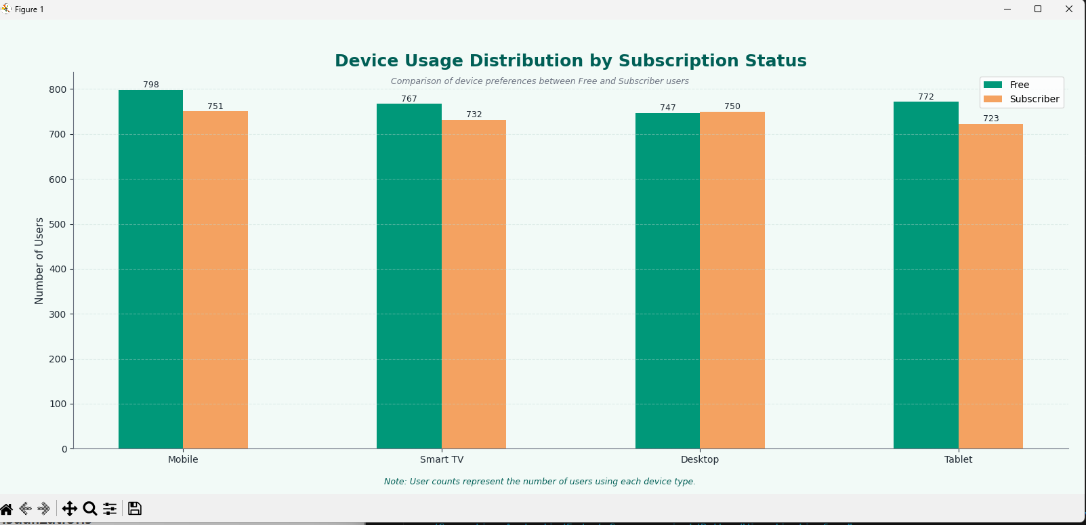

Description
This figure compares the number of Free and Subscriber users across different device types.
Key Insights
- Mobile devices are the most commonly used platform among both Free and Subscriber users.
- Device usage patterns are fairly similar between the two subscription groups.
- Desktop users exhibit nearly identical counts between Free and Subscriber segments.
- Tablet usage is slightly higher among Free users.
Business Implications
- Mobile optimization should remain a key focus area, as it represents the largest user segment.
- Similar device usage patterns suggest that subscription decisions are influenced more by content preferences than by device type.
- Ensuring a consistent experience across all devices will help maintain user satisfaction and engagement.

  - 5. Overall Findings
The analysis identified several important trends:
- Subscriber users generally assign higher ratings to movies than Free users.
- Drama and Comedy are the most popular genres across both user segments.
- Age distributions are similar between Free and Subscriber users, suggesting that subscription decisions are influenced more by content preferences than demographics.
- Free and Subscriber users are almost evenly distributed, indicating strong subscription adoption.
- User engagement is geographically diverse and relatively balanced across countries.
- Mobile devices are the most preferred platform among users, emphasizing the importance of mobile optimization.
  - 6. Recommendations
Based on the analysis, the following recommendations are proposed:
Content Strategy
- Continue investing in Drama and Comedy content, which generate the highest engagement.
- Promote highly rated movies among Free users to encourage subscription upgrades.
Personalization
- Utilize differences in movie ratings and genre preferences to improve recommendation systems.
- Develop targeted campaigns tailored to user preferences.
Subscription Growth
- Focus conversion campaigns on countries with larger Free user populations.
- Strengthen retention initiatives in markets with stronger Subscriber representation.
Platform Experience
- Prioritize mobile-first design and optimize the streaming experience across devices.
- Maintain a consistent experience across all supported platforms.

  - 7. Conclusion
This analysis demonstrates that user behavior, content preferences, and engagement patterns are broadly consistent across subscription groups. Content quality and viewing preferences appear to have a greater influence on subscription decisions than demographic or device characteristics. These findings provide valuable insights to support content acquisition, personalization strategies, user retention, and long-term subscription growth.

